ResearchResearch

🔹 Definition
# Source: ScreenShots Source: Provided by: [Persons Table -> ID Column: 1, Name_En Column: Motasem Essam] -> Tool: [Lightshot Program] -> From [Site: https://www.researchresearch.com/] on [11/13/2025]
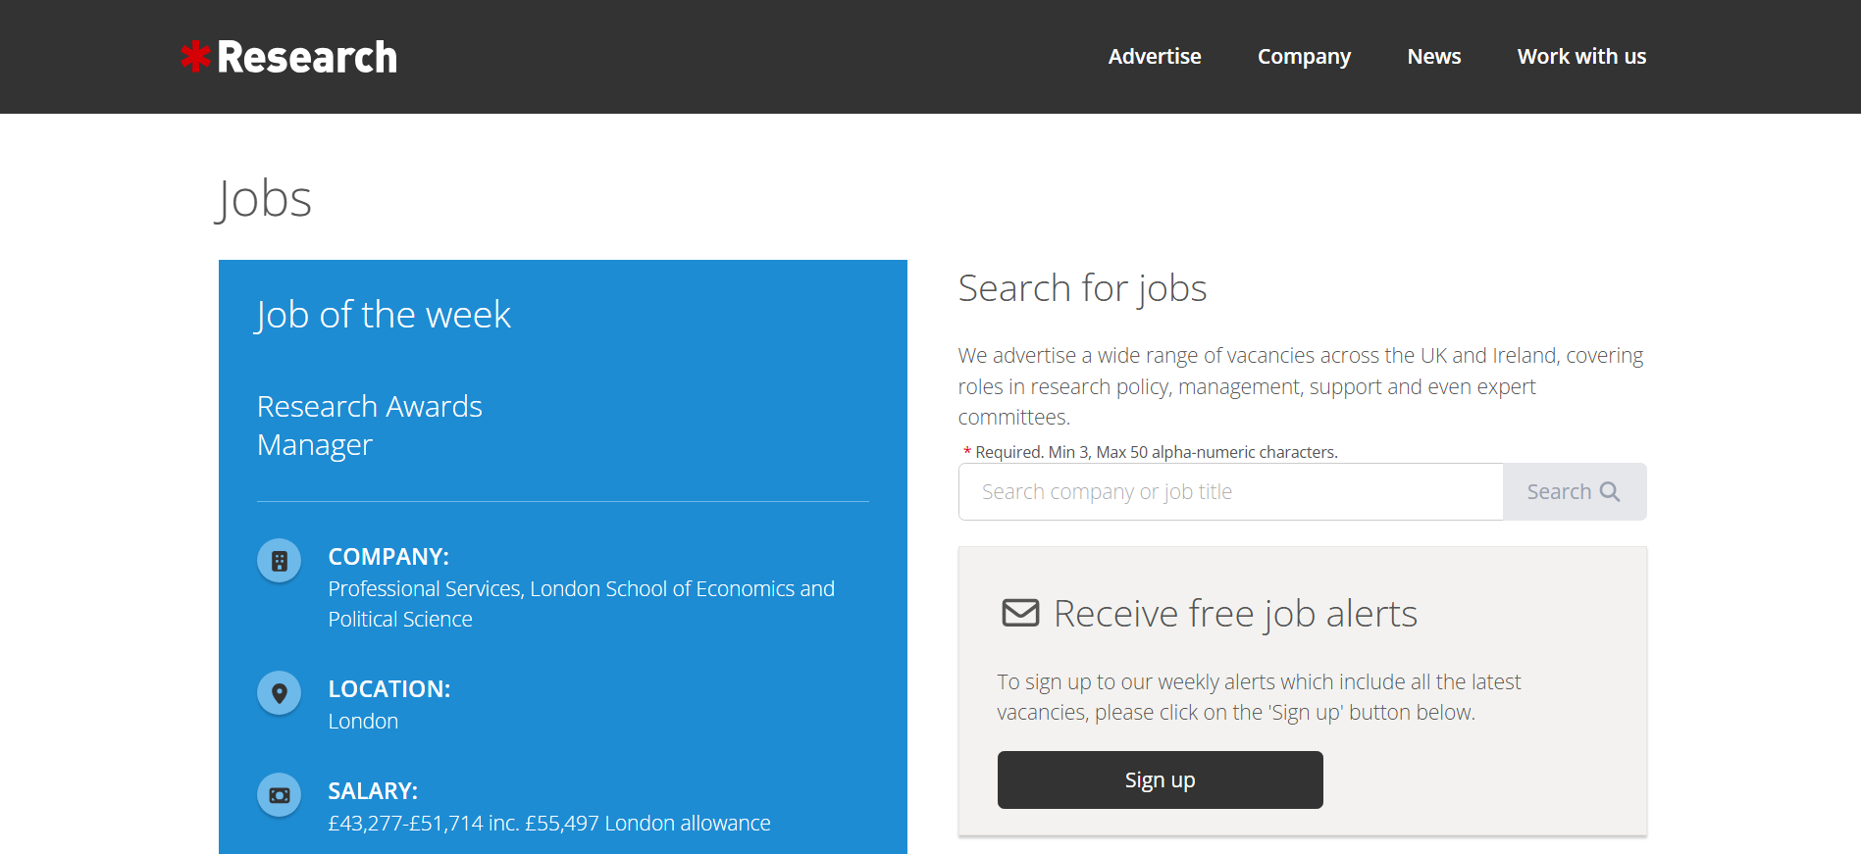
# Source: AI Source: Provided by: [Data Path: Persons Table -> ID Column: 1, Name_En Column: Motasem Essam] -> From: [ChatGPT] on [11/13/2025]
ResearchResearch (often styled as Research Professional News or Research Research) is a well-known online news and funding information platform that serves the global research community. Here’s a clear breakdown:

🔍 What It Is
# Source: AI Source: Provided by: [Data Path: Persons Table -> ID Column: 1, Name_En Column: Motasem Essam] -> From: [ChatGPT] on [11/13/2025]
ResearchResearch.com is a website that provides:
- Research policy news — updates on science funding, government research policy, and academic developments around the world.
- Funding opportunities — searchable databases of research grants, fellowships, and funding calls.
- Analysis and commentary — expert insights into research management, higher education, and innovation policy.

🏢 Who Runs It
# Source: AI Source: Provided by: [Data Path: Persons Table -> ID Column: 1, Name_En Column: Motasem Essam] -> From: [ChatGPT] on [11/13/2025]
It’s operated by Research Professional News, which is part of the Ex Libris / Clarivate group (a major provider of research management and academic information tools).

🌍 Who Uses It
# Source: AI Source: Provided by: [Data Path: Persons Table -> ID Column: 1, Name_En Column: Motasem Essam] -> From: [ChatGPT] on [11/13/2025]
- Universities and research institutions subscribe to it to track research funding opportunities.
- Researchers use it to find grants and stay informed about research policy.
- Administrators and policy professionals follow its news coverage for strategic planning.

💡 Summary
# Source: AI Source: Provided by: [Data Path: Persons Table -> ID Column: 1, Name_En Column: Motasem Essam] -> From: [ChatGPT] on [11/13/2025]

Aspect | Details
Website | https://www.researchresearch.com
Type | Research news & funding information platform
Focus | Science policy, funding, and higher education
Audience | Researchers, universities, funding managers
Ownership | Part of Clarivate (via Ex Libris)

